Revue Stage: Accessibility Overview

**1601 Johnston St., Vancouver BC V6H 3R9**

# Signage

* **Visible at front entrance**
* 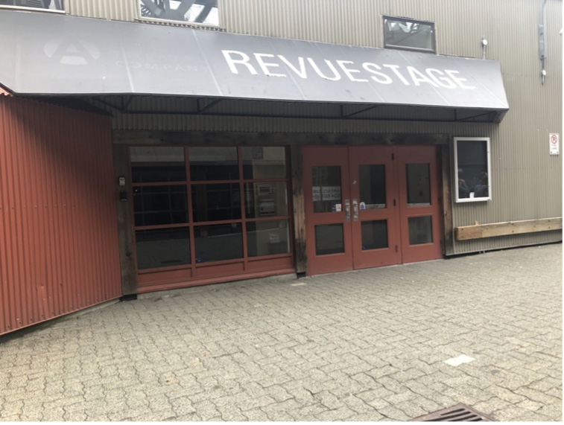**No braille**

**Image description: Outside doors and signage to Revue Stage**

# Parking and Transit

* **4 accessible spots in front of Granville Island Stage building with room to exit vehicle on left and right**
* **Parking spaces on level ground**
* **Bus #50 stops 200 m from entrance**

# Exterior

* **Main entrance is wheelchair, walker, and mobility scooter accessible**
* **Ground is flat**

# Interior

* **Accessible entrance door is > 33 3/4” wide and threshold is flush with floor; door has an automatic button**
* **Hallways are at least 59” wide**
* **First row of theatre is accessible for wheelchairs, walkers, and mobility scooters**
* 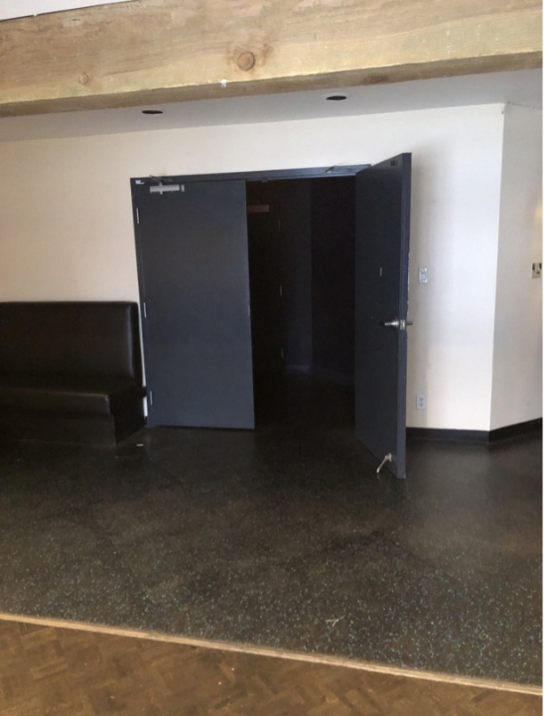**All other rows are accessed by stairs with 35” high handrail**

Image description:

**Interior doorway to the theatre.**

# Lighting

* **Fluorescent, incandescent, and halogen lighting**
* **Some shows may use strobe lights (Please check show description)**

# Stage/Backstage

* **2 steep ramps up to the stage; would require motorized chair or assistance**
* 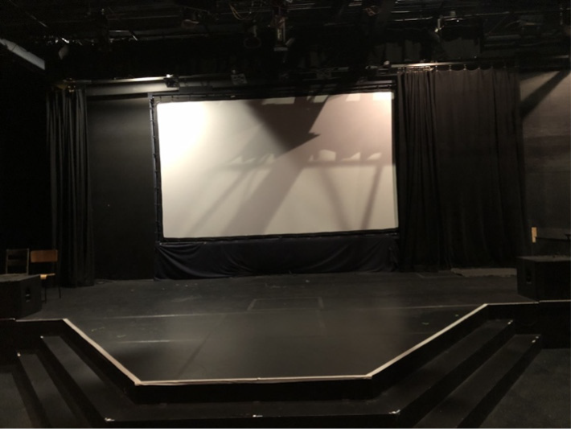**Wings can be converted into a stair-free green room**

**Image description: Stage with screen in the background.**

# Seating

* **Venue seating: 16x17” folding chairs**
* **Front row can be removed for wheelchair, scooter, or mobility scooter users, chairs can be included for their companions**
* **Room for walkers in the front row; ushers can assist with walker storage**
* 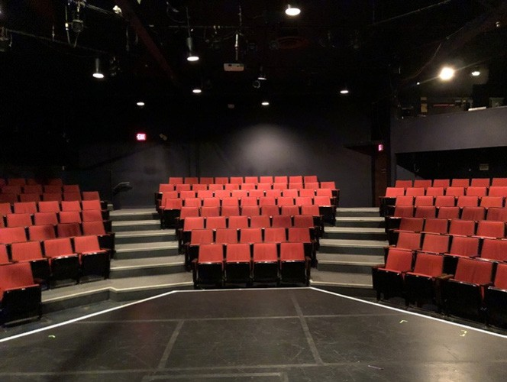**Rest seating: tall stools and benches in the lobby**

Image description:

**Red theatre seats.**

# Bathrooms

* **Gender neutral bathroom**
* **2 accessible stalls with handrails**
* 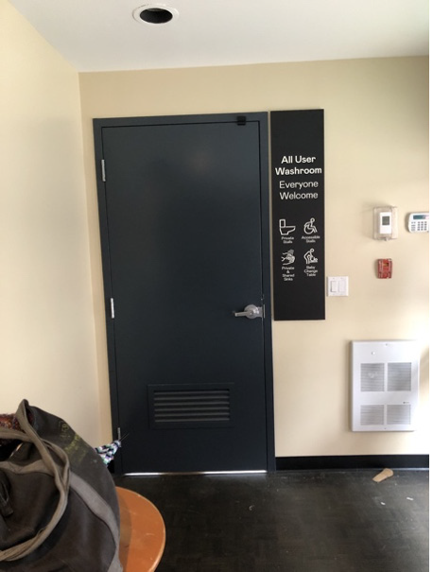**No automatic door button**

Image description:

**Gender neutral bathrooms with toilets, baby changing station, and mobility device accessible toilet.**

# Assistive Listening Device

* **Infrared system headsets available with advance reservation**

# Guide Dogs

* **Room for guide dogs at seat**
* **Rest/toilet area for dogs outside of venue**