Performance Works: Accessibility Overview

1218 Cartwright St., Vancouver BC V6H 3R8

# Signage

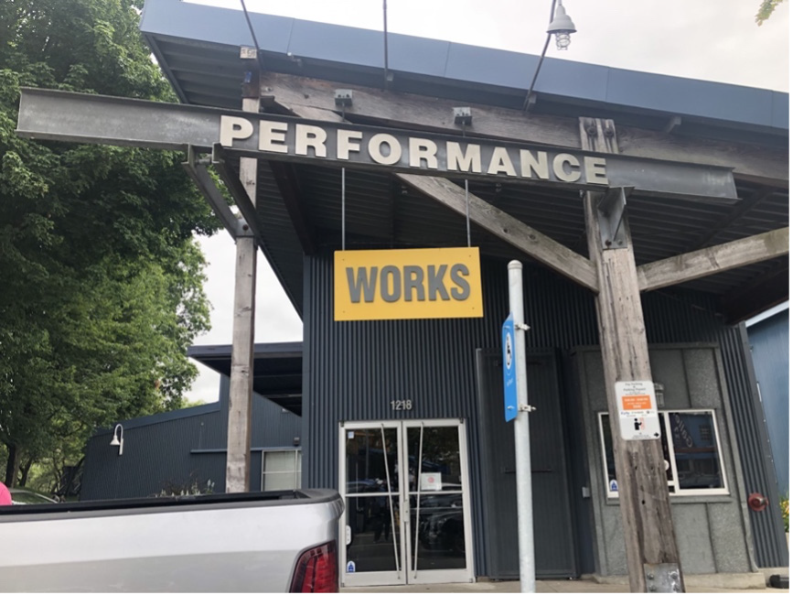

* **Visible at the front**

**entrance**

* **Only in English**
* **No braille**

Image description:

Outside signage for Performance Works, with doors at the bottom of the image.

# Parking and Transit

* **One accessible spot in front of entrance with room to exit vehicle at left and rear; drop off space near entrance**
* **Parking spaces on sloped ground**
* **Bus #50 stops 200m from entrance**

# Exterior

* **Main entrance is wheelchair, walker, and mobility scooter accessible**
* **Ground has curb cuts but not ramps**

Image description:

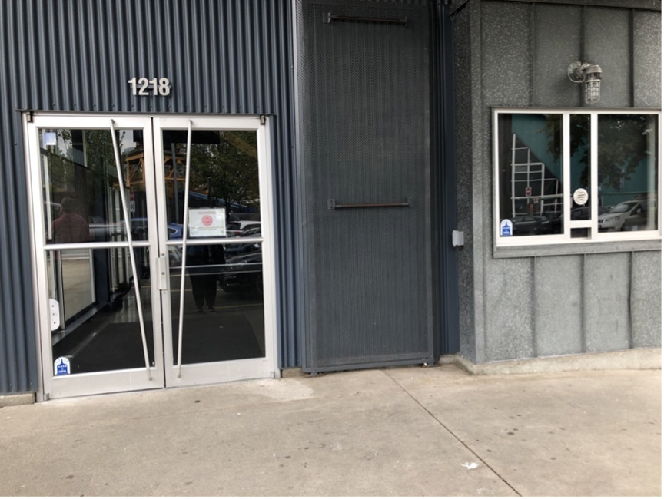

Outside doors of Performance Works.

# Interior

* **Accessible entrance door is 44” wide and threshold is flush with floor**
* **Doors are not automatic but can be propped open**
* **Stair-free space (all one floor).**
* **Floor incline: sometimes greater than 1:12**
* **Hallways are at least 59” wide**

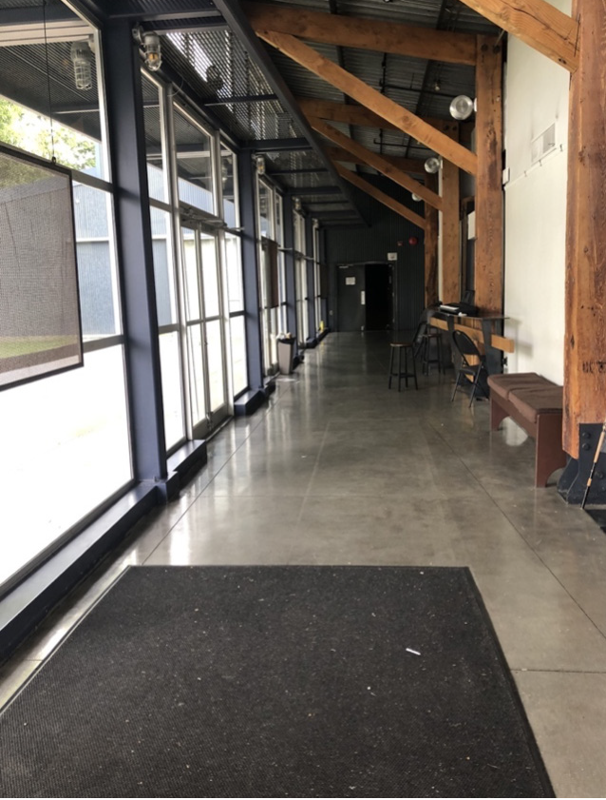

Image description:

Interior hallway towards theatre with floor to ceiling windows on the left and benches on the right.

# Lighting

* **Fluorescent, incandescent, and halogen lighting**
* **Some shows may use strobe lights. (Please check show description)**

# Stage/Backstage

* **Stage is 2 feet high with 3-4 steps**
* **Not wheelchair accessible**

**Image Description:**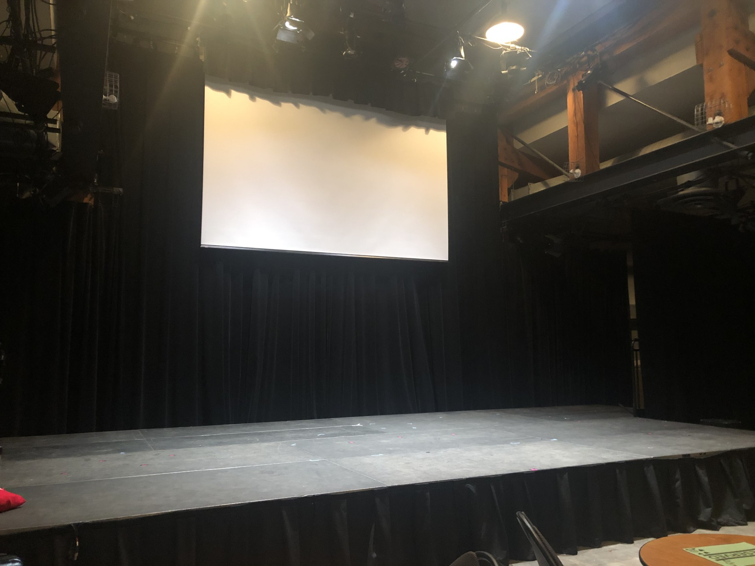

**Stage with black curtains around**

**The stage and white screen**

# Seating

* **Venue seating: 16x16” folding chairs**
* **Front row can be removed for wheelchair and scooter use, chairs can be included for their companions**
* **Room for walkers in the front row; ushers can assist with walker storage**
* **Rest seating: bench in the hallway**

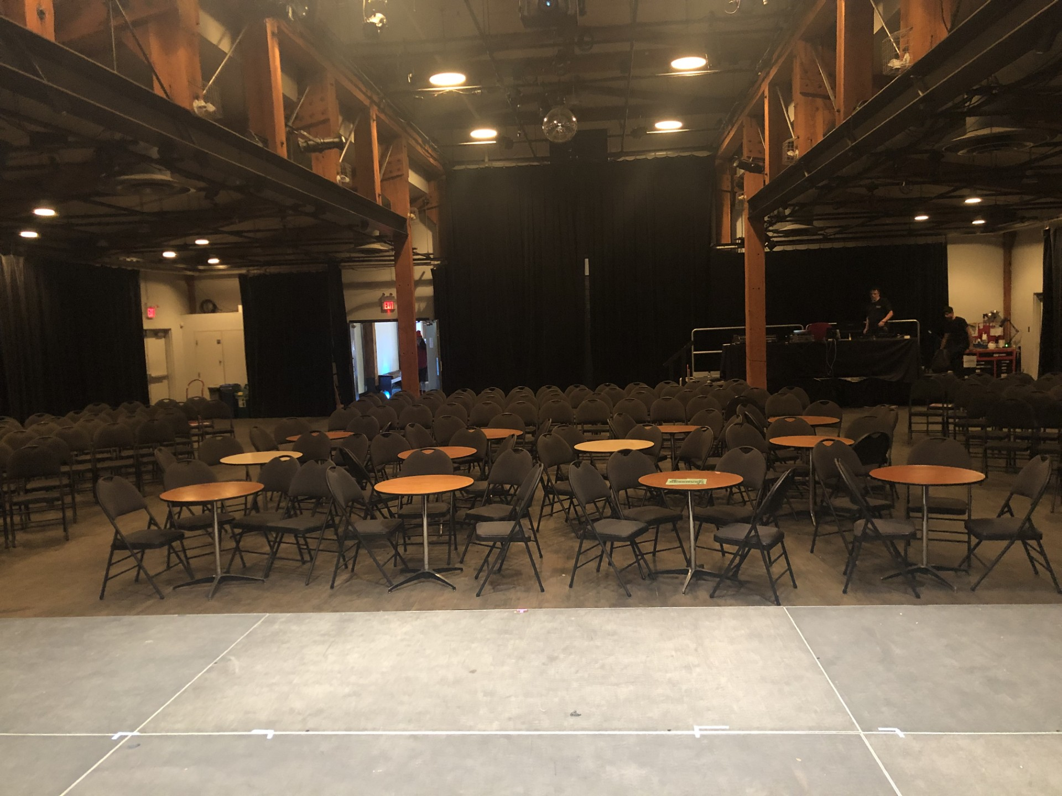

**Image Description: black foldable chairs with round tables in the forefront**

# Assistive Listening Arrangements

* **No infrared or FM systems**

# Guide Dogs

* **Room for guide dogs at seat**
* **Rest/toilet area for guide dogs outside of venue**

# Bathrooms

* **2 gender neutral bathrooms, 1 accessible stall in each**
* **No automatic doors**

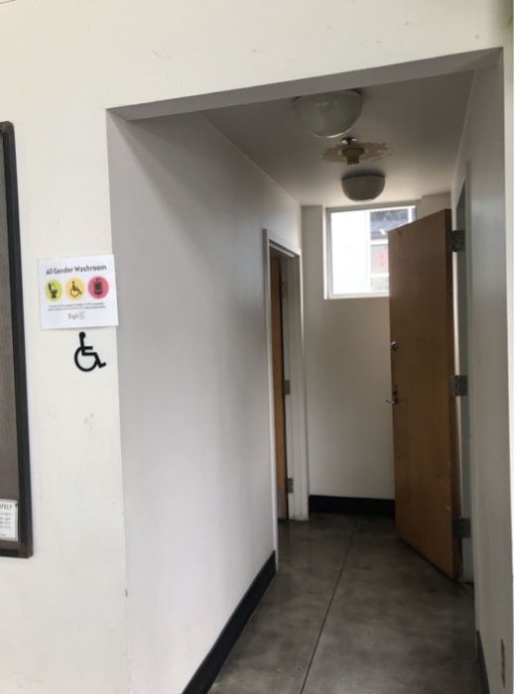

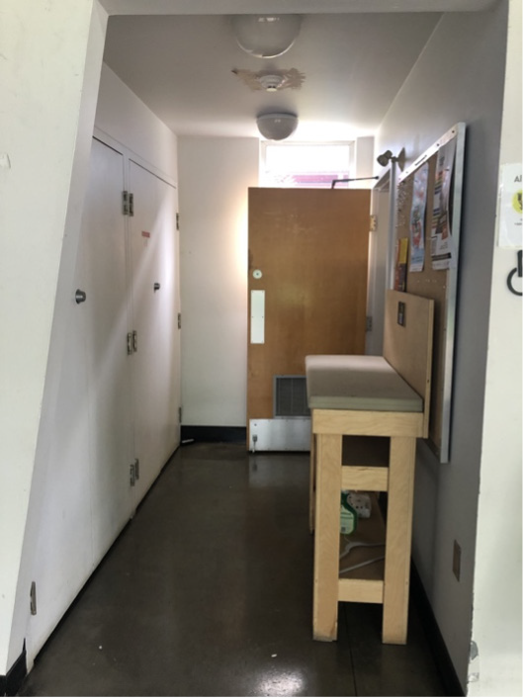

Image description:

Image number 1, gender neutral bathroom with urinals and toilets Image number 2, gender neutral bathroom with toilets and baby changing station