Box Office: Accessibility Overview
1398 Cartwright St., Vancouver BC V6H 3R8

Signage

- Visible at the front
entrance
- Only in English
- No braille

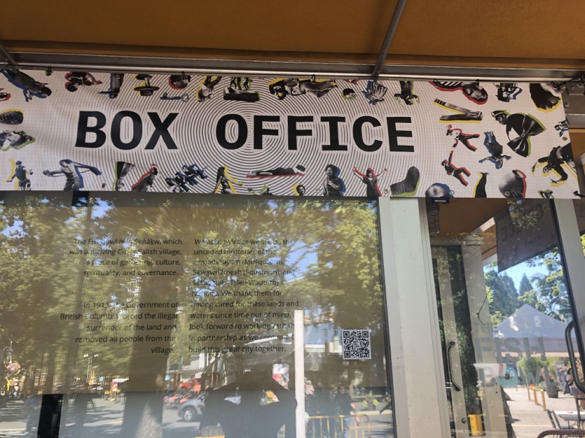
Image: A sign on a building

Parking and Transit
- Drop off space near entrance
- Bus #50 stops 200m from entrance

Exterior
- Main entrance is wheelchair, walker, and mobility scooter accessible
- Sloped ground

Interior

- Accessible entrance door

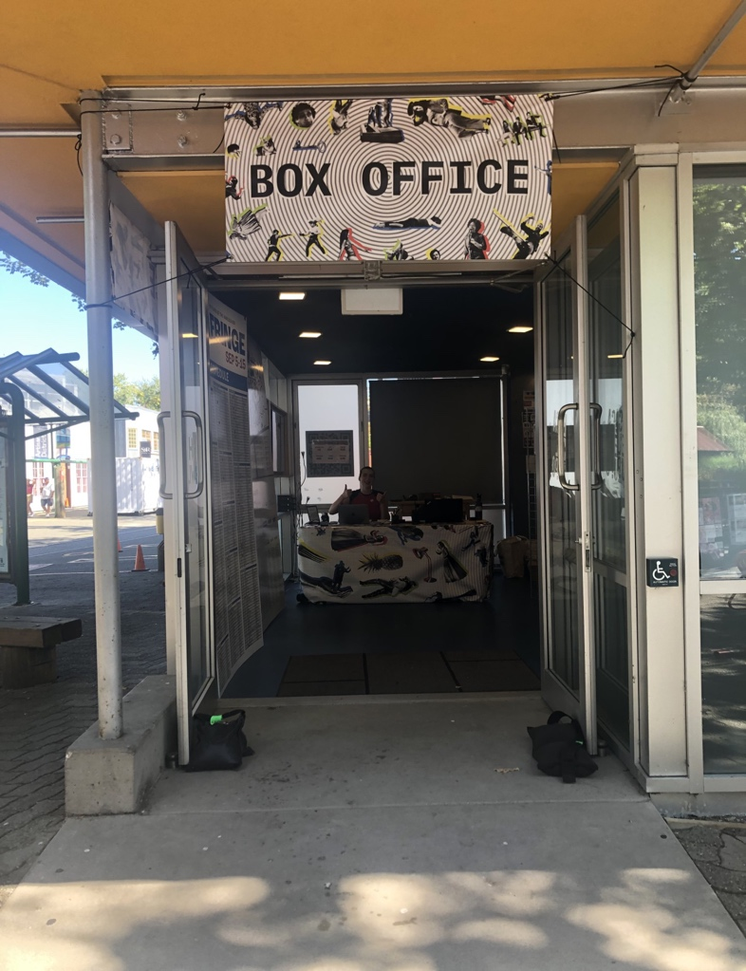
Image: A sign on the front of a building
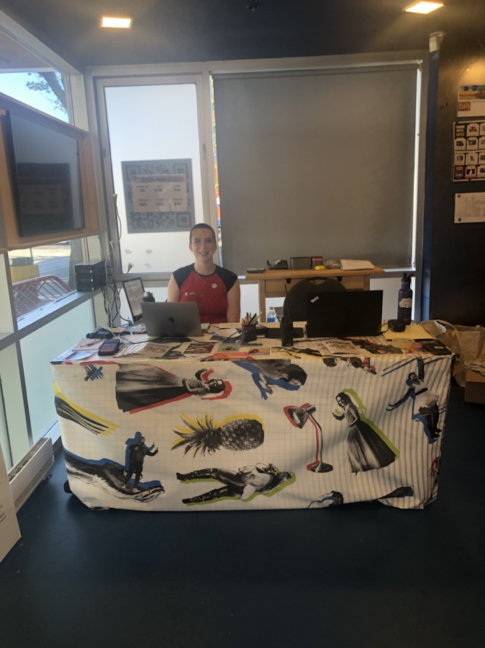
Image: A person sitting at a desk with a table covered with a table cloth

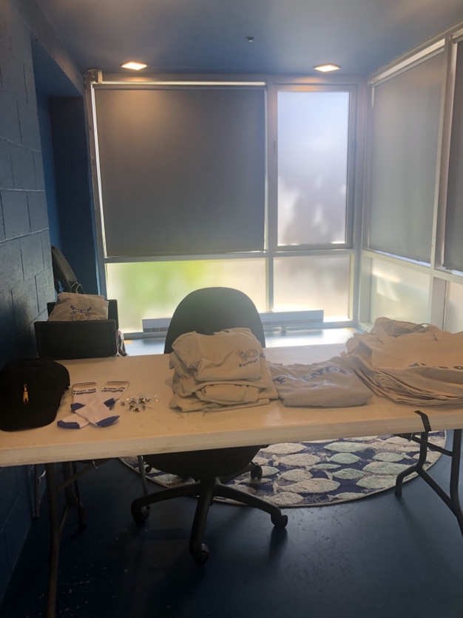
Image: A desk with a chair and a stack of folded clothes

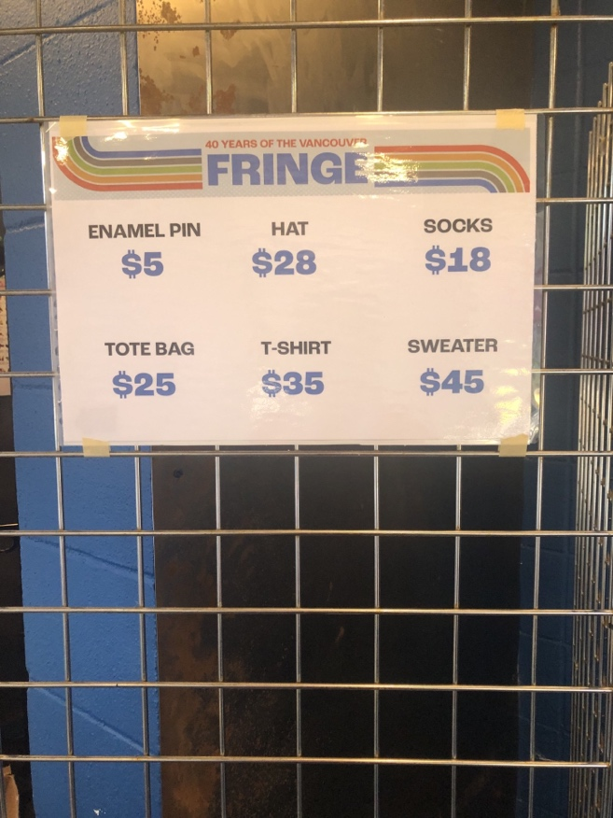
Image: A sign of merchandise prices on a wire fence
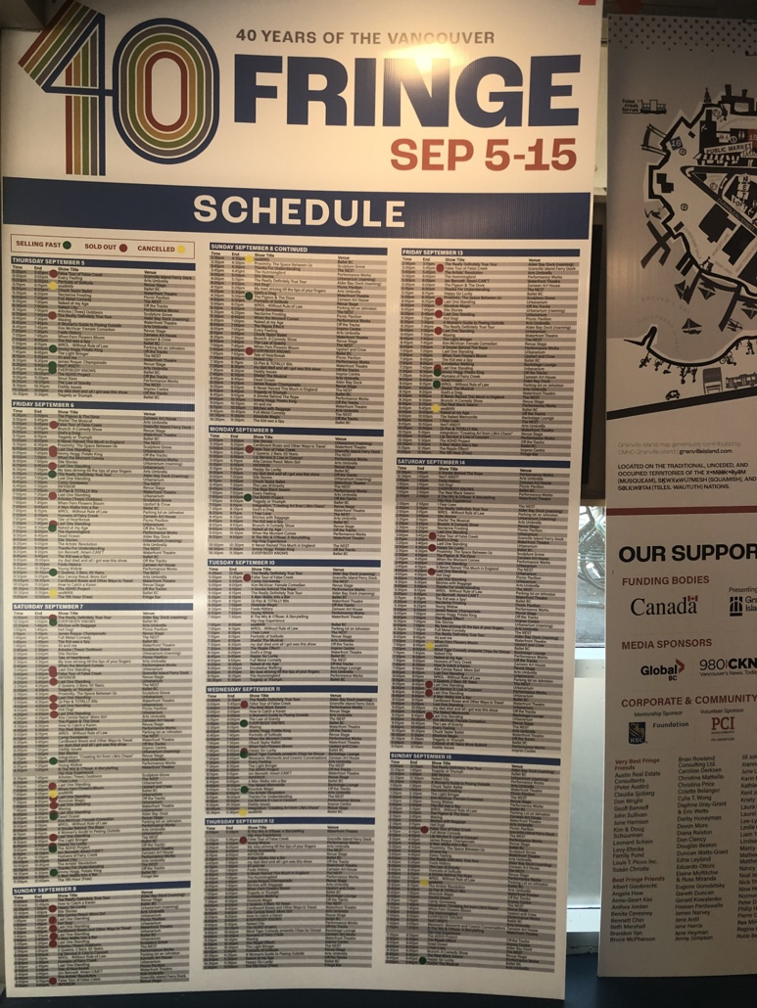
Image: A schedule board with many different colored names

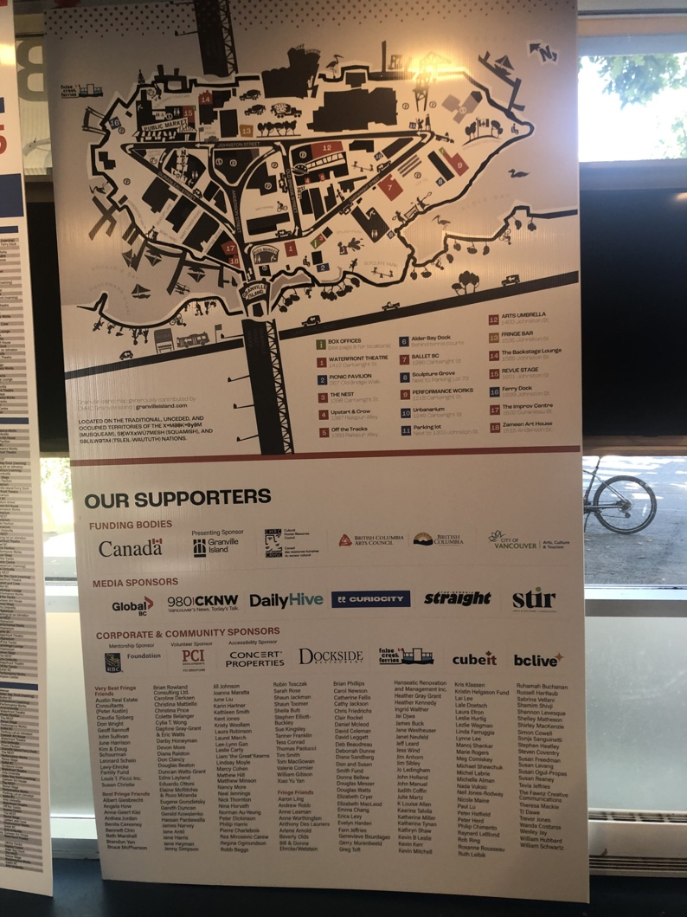
Image: A sign with a map of Granville Island

Lighting
- Halogen lighting

Seating
- No seating for patrons

Assistive Listening Arrangements
- No infrared or FM systems

Guide Dogs
- Room for guide dogs in box office
- Rest/toilet area for guide dogs outside of box office

