Waterfront Theatre: Accessibility Overview

**1412 Cartwright St., Vancouver BC V6H 3R7**

# Signage

* **Visible at front entrance**
* **No braille**

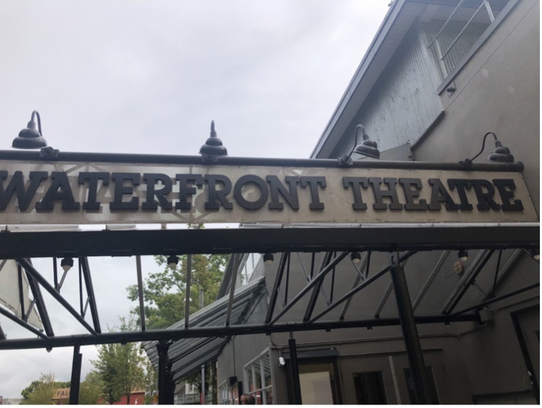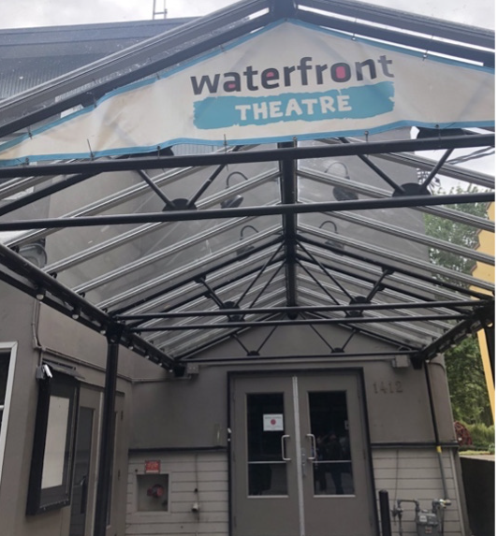

Image description:

**Outside signs for Waterfront Theatre**

# Parking and Transit

* **1 accessible parking spot in front of entrance; backs out into traffic flow**
* **1 accessible parking spot in lot beside the building with room to exit vehicle on left, right, and rear**
* **Parking spaces on sloped ground**
* **Bus #50 stops 200m from entrance**

# Exterior

* **Main entrance is wheelchair, walker, and mobility scooter accessible**
* **Ground has curb cuts but no ramps**

# Interior

* **Accessible entrance door is 5’9” wide; threshold is flush with floor**
* **Doors are not automatic but can be propped open**
* **Hallways are at least 59” wide**
* **Main floor is wheelchair, walker, and mobility scooter accessible**
* **Ramp at entrance to theatre and lounge - no handrails, 1:12 gradient**
* **Balcony accessed by carpeted stairs with handrail- no elevator**

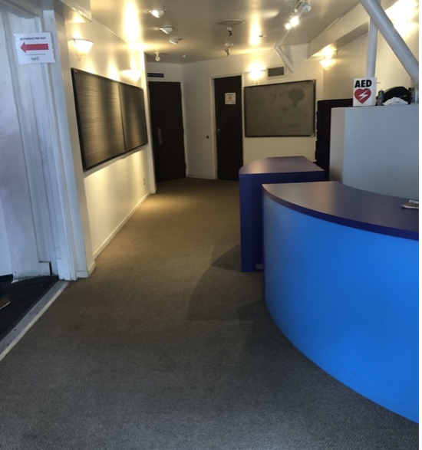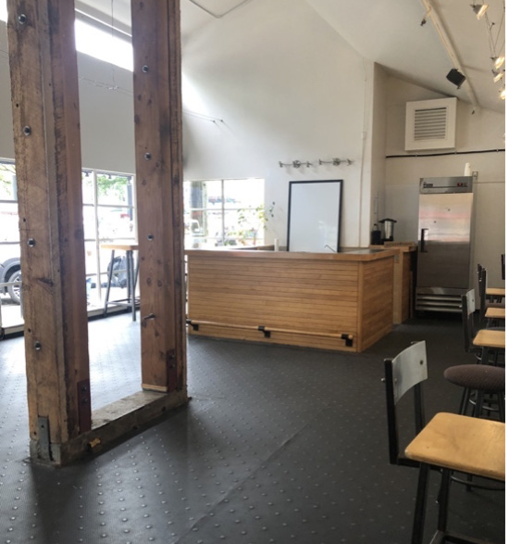

Image description:

**Image number 1, hallway to theatre. Image number 2, bar area.**

# Lighting

* **Incandescent and halogen lighting**
* **Some shows may use strobe lights (Please check show description)**

# Stage/Backstage

* **Steps up to stage; no ramp**
* **Greenroom is wheelchair, walker, and mobility scooter accessible**

# Seating

* **Venue seating: 16x16” folding chairs**
* **Front row can be removed for wheelchair and scooter use, chairs can be included for their companions**
* **Room for walkers in front row; ushers can assist with walker storage**
* **Unobstructed view for lip reading and interpretation**
* **Rest seating: bench in the hallway**

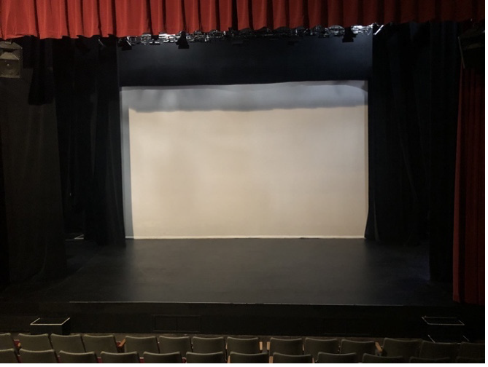 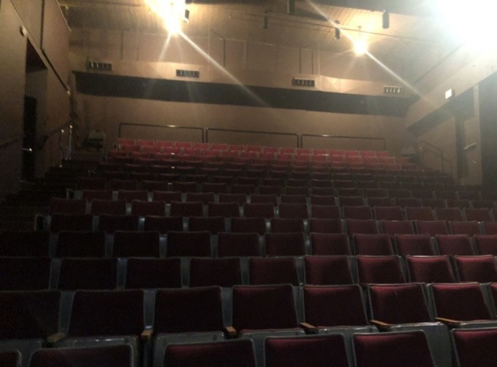

Image description:

**Image number 1, stage with screen at the back. Image number 2, seating in the theatre.**

# Bathrooms

* **2 gender neutral bathrooms, 1 accessible stall in each**
* **No automatic doors**

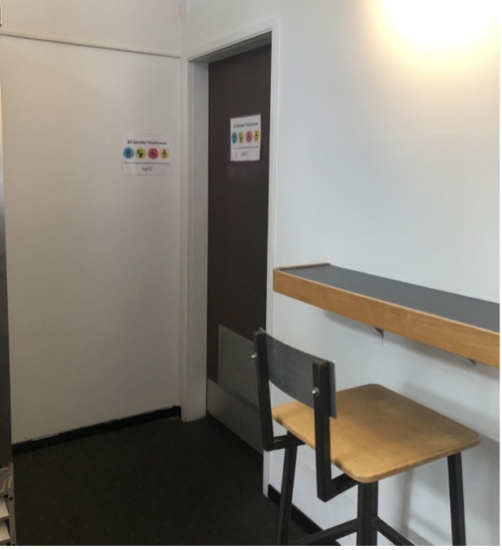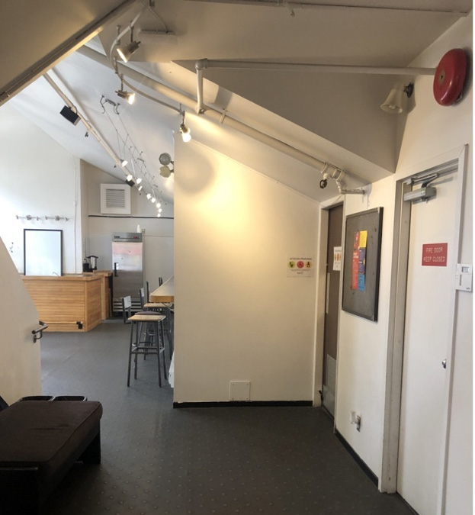

Image description:

**Image number 1, gender neutral bathroom with urinals and toilets (L). Image number 2, gender neutral bathroom with toilets (R).**

# Assistive Listening Arrangements

* **No infrared of FM systems**

# Guide Dogs

* **Room for guide dogs at seat**
* **Rest/toilet area for guide dogs outside of venue**