The NEST: Accessibility Overview

**Festival House, 1398 Cartwright St 3rd Floor, Vancouver BC V6H 3R8**

# Signage

* **Visible at front entrance and throughout stairwell**
* **No braille**

# Parking and Transit

* **1 accessible parking spot in front of entrance; backs out into traffic flow**
* **1 accessible parking spot beside building with room to exit vehicle on left, right, and rear**
* **Parking spaces on sloped ground**
* **Bus #50 stops 200m from entrance**

# Exterior

* **Main entrance is wheelchair, walker, and mobility scooter accessible**
* 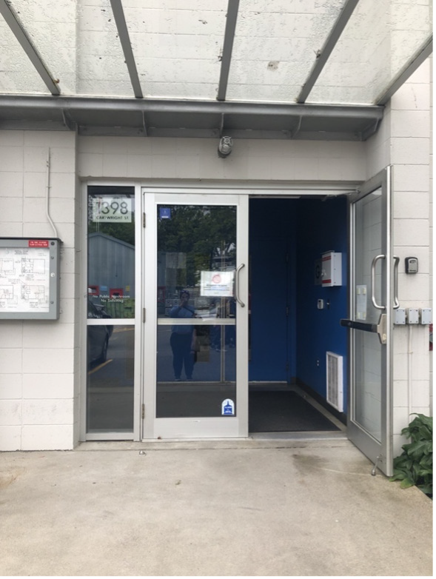**Ground is on an incline leading up to door**

Image description:

**Outside doors of The NEST.**

# Interior

* **Accessible entrance doorway is 73” wide and threshold is flush with floor**
* **Doors are not automatic but can be propped open**
* **Venue is on the 3rd floor of the building**
* **Access by elevator or 2 flights of stairs with 32” high railing**
* **(Elevator makes rattling sounds but is safe and inspected regularily**
* **Hallways are 42” wide at narrowest point**

Image description:

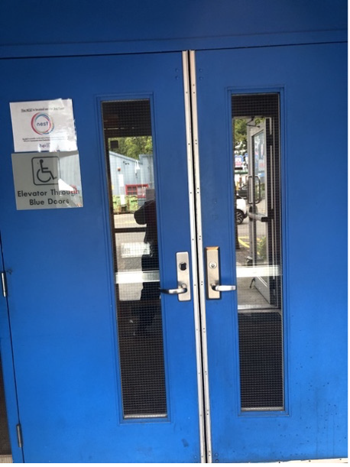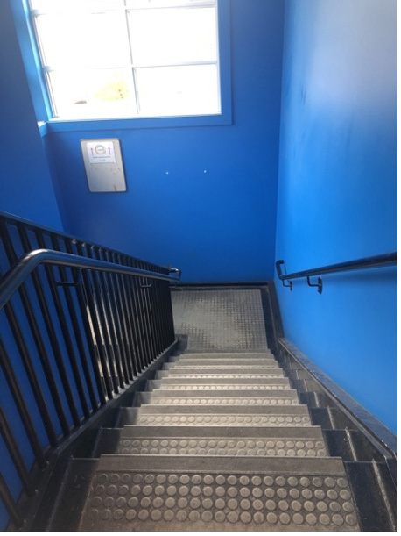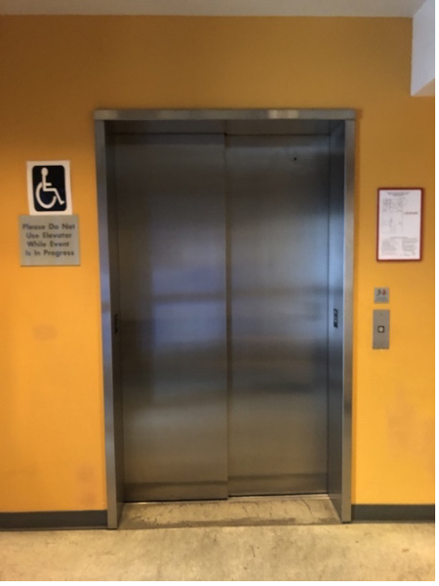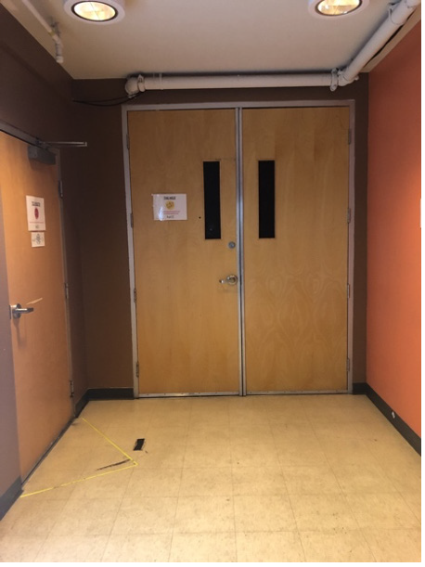

**Image number 1, interior blue doors to elevator.**

**Image number 2, ground floor elevator to venue**

Image description:

**Image number 1, stairs to the theatre.**

**Image number 2, indoor entrance to the theatre.**

# Lighting

* **Halogen and LED lighting**
* **Some shows may use strobe lights (Please check show description)**

# Stage/Backstage

* **Stage is fully accessible - not raised**
* 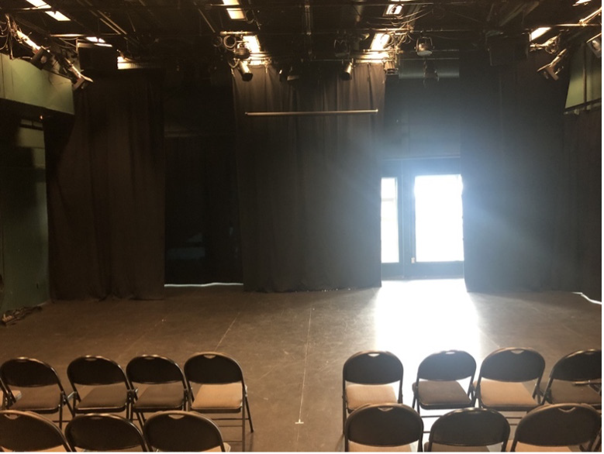**Greenroom is 8’x12’**

Image description:

**Stage with blackout curtains.**

# Seating

* **Venue seating: folding chairs**
* **Front row can be removed for wheelchair and scooter users, chairs can be included for their companions**
* **Room for walkers in front row; ushers can assist with walker storage**

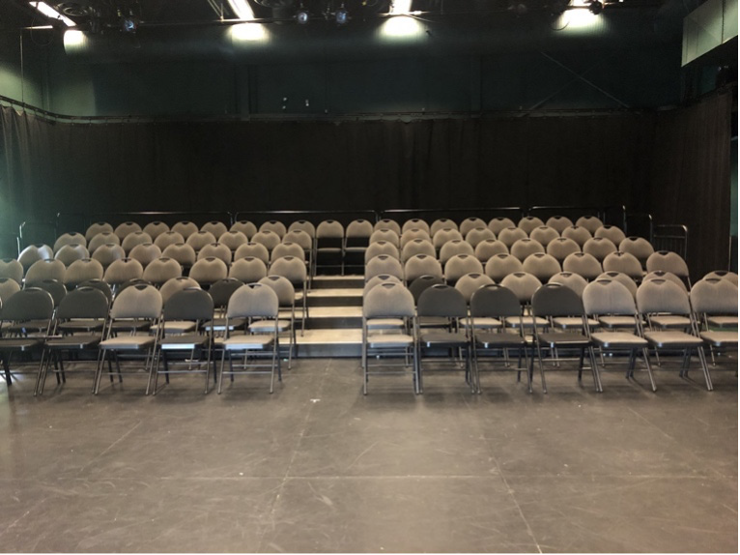Image description:

**Seating, with moveable folding chairs**

# Bathrooms

* **2 gender neutral bathrooms, each with 1 accessible stall**
* **No automatic door**

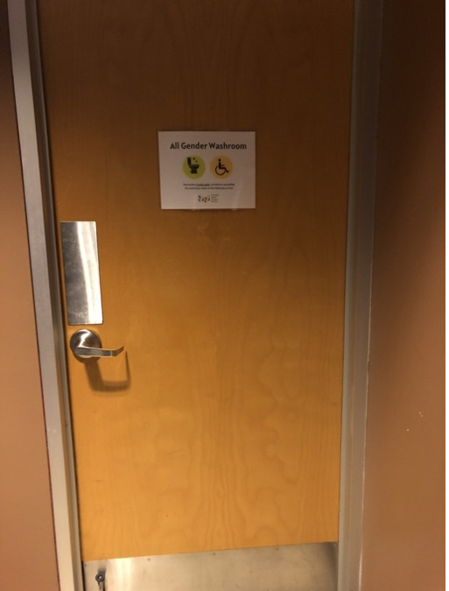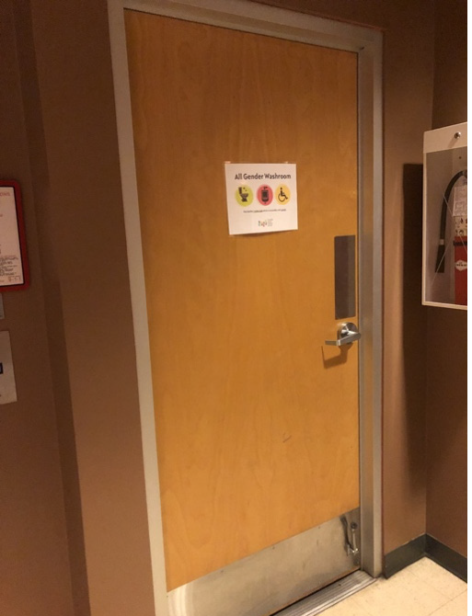

Image description:

**Image number 1, gender neutral bathroom with urinal and toilet Image number 2, gender neutral bathroom with toilets**

# Assistive Listening Arrangements

* **No infrared or FM systems**

# Guide Dogs

* **Room for guide dogs at seat**
* **Rest/toilet area for guide dogs outside of venue**