Arts Umbrella: Accessibility Overview

**1400 Johnston St., Vancouver BC V6H 3S1**

# Signage

* **Visible at the front entrance**
* **No braille**

# Parking and Transit

* **5 minute drop-off area on Johnston Street, alongside the building**
* **2 accessible parking stalls at the end of the ground floor of the multi-level parkade on Old Bridge Road, with level access to the front entrance**

# Exterior

* **Main entrance is wheelchair, walker, and mobility scooter accessible, with a push button automatic door**
* 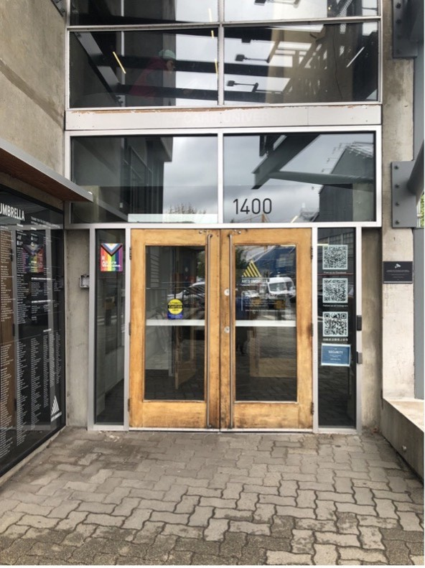**No curb from the road or the parkade**

**Image description: Outside Doors of Arts Umbrella**

# Interior

* **The accessible entrance (main entrance) is 35” wide; threshold is flush with floor**
* **All four floors have elevator and/or ramp access**
* **The ramp from the 4th floor elevator to the accessible washroom is 7%**
* **All stairs and ramps have handrails, except for the theatre**

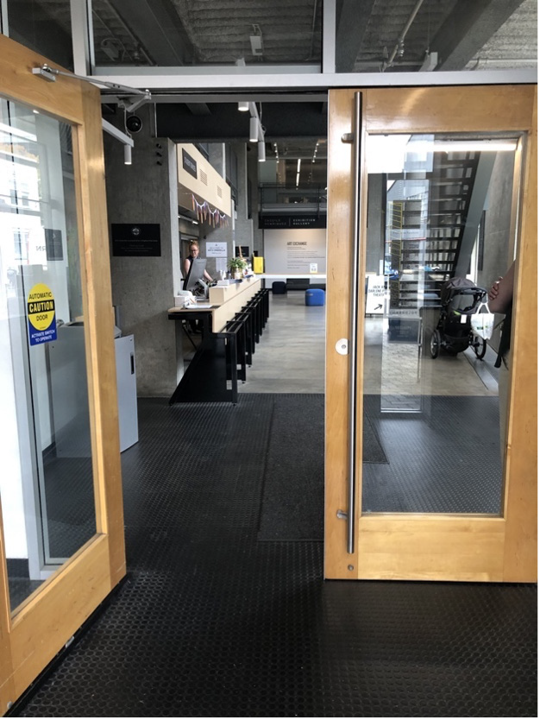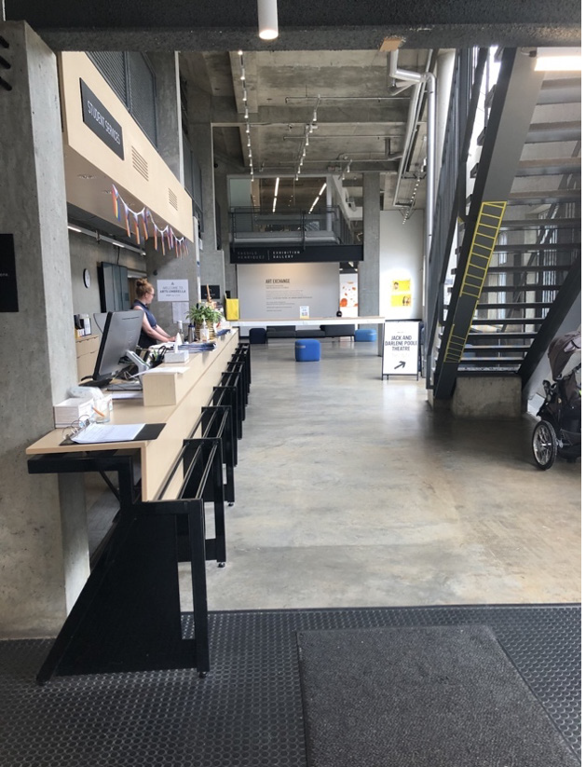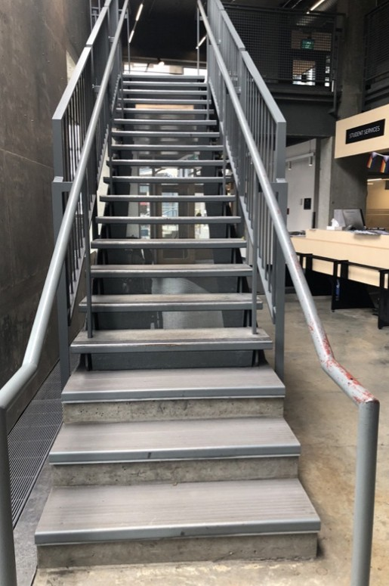

Image descriptions:

**Image number 1, interior doorway to stairs and elevator. Image number 2, corridor to stairs and elevator**

**Image number 3, interior stairs to the theatre**

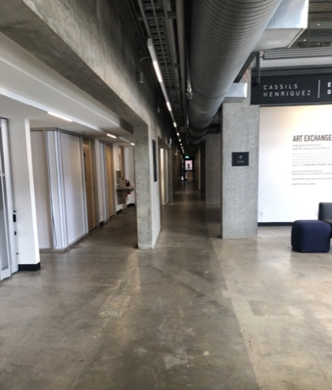 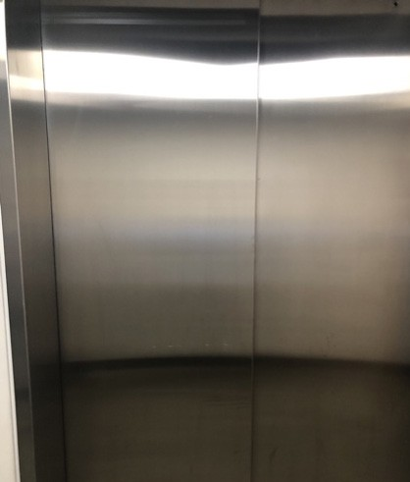 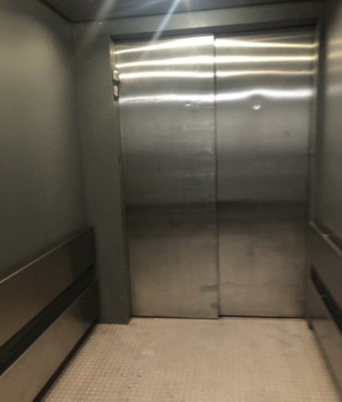

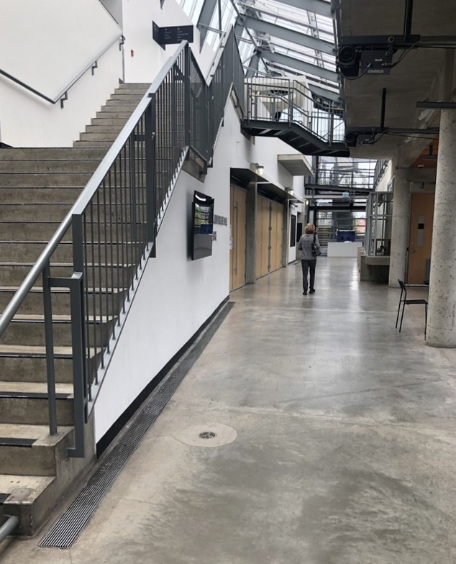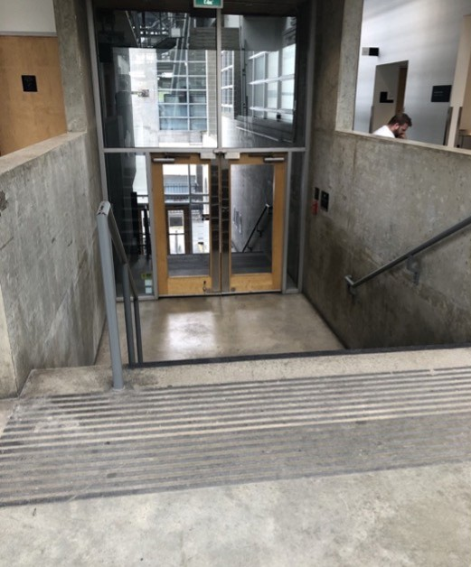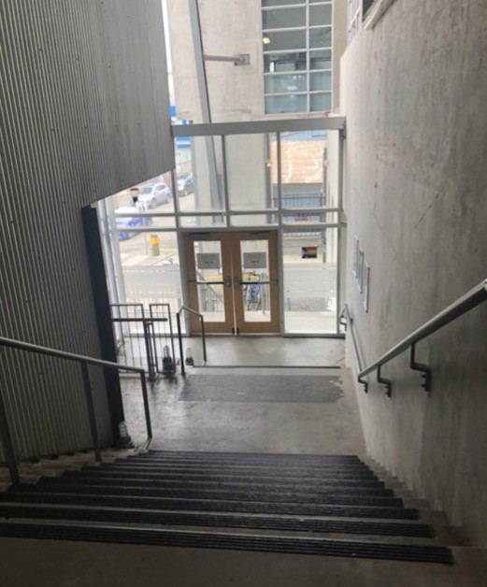

Image descriptions:

**Image number 1, corridor to the elevator Image number 2, elevator doors**

**Image number 3, inside of the elevator**

**Image number 4, corridor to the theatre. (Doors on the left)**

**Image number 5, stairs and doors leaving the theatre to outside (floor 3 to floor 2)**

**Image number 6, stairs and doors leaving the theatre to outside (floor 2 to floor 1)**

# Lighting

* **There is LED lighting throughout the building**
* **Some shows may have strobe lights - please check show description**

# Stage/Backstage

* **Ramp from the stage to the green room is 8.3%**
* **Personnel lift to control booth**
* **Greenroom entrance door is 35” wide**
* **Washrooms and shower are not accessible**

# Seating

* **Venue seating: 19” wide**
* **There are no designated wheelchair spaces, but wheelchairs are accommodated adjacent to the entrance door, with level access from the atrium**
* **Walkers can be kept at seats provided the patron is seated at the edge**
* **Unobstructed view for lip reading and interpretation**

# Bathrooms

* **The 1st and 3rd floors have universal washrooms**
* **The accessible washroom is on the 4th floor**
* **The doors are not automatic**

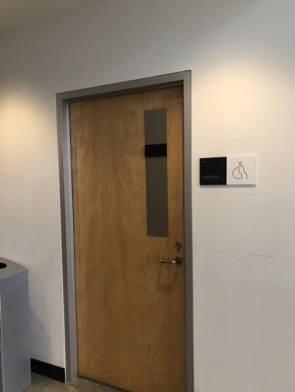 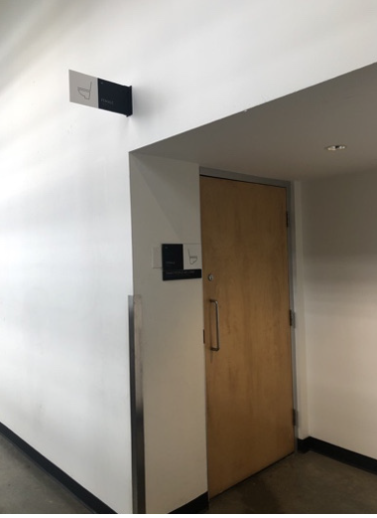 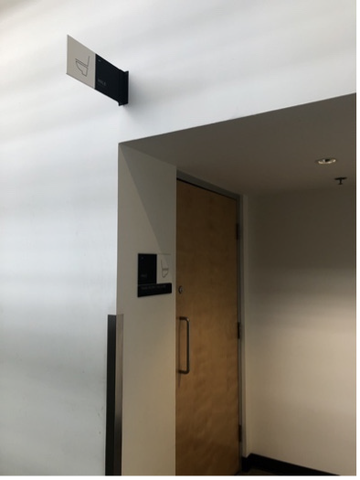

Image descriptions:

**Image number 1, mobility device accessible washroom (4th floor), seperate from other washrooms.**

**Image 2 & 3, gender neutral bathrooms with toilets.**

# Assistive Listening Arrangements

* + **4 Sennheiser-assisted listening devices**

# Guide Dogs

* + **Ask AU - Room for guide dogs at seat**
  + **Rest/toilet area for guide dogs outside of venue**